

Check your teaching – Quiz-based Teaching feedback Web Application

Advanced Web Programming

Asian Pacific University

By Sabrina El Hassani

**Table of Contents**

1. Introduction & Project Plan
2. Design  
   2.1 Entity Relationship Diagram (ERD)  
   2.2 Data Dictionary  
   2.3 Website Navigational Structure/ Process flow diagrams  
   2.4 Web interfaces (screenshots)
3. Implementation  
   3.1 Backend Architecture  
   3.2 Authentication and User Management  
   3.3 Teacher Features  
   3.4 Student Features  
   3.5 AI Quiz Generation (Gemini API – Bonus)
4. Error Handling & Robustness
5. Conclusions & Future Enhancements
6. References

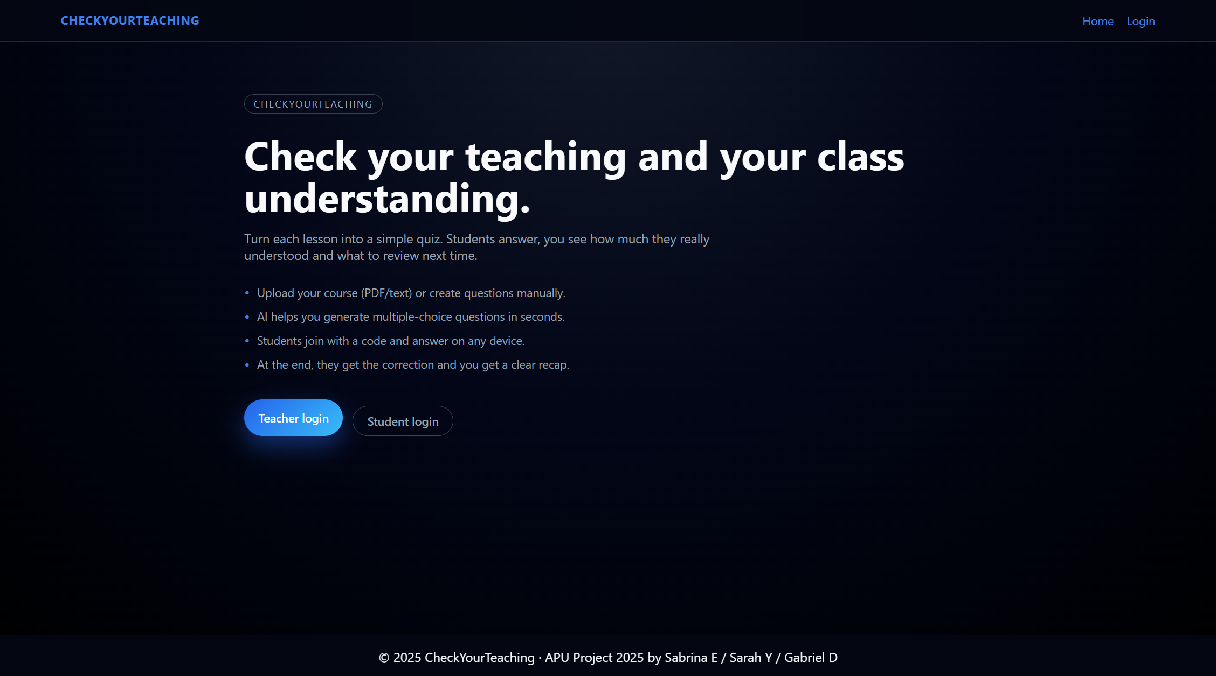

# 1. Introduction & Project Plan

Teaching is only effective if students actually understand what has been taught. In a real classroom it is often difficult for a lecturer to know, at the end of a session, which concepts are clear, and which ones need to be reviewed. Our project, CheckYourTeaching, was designed exactly for this problem.

CheckYourTeaching is a full-stack web application designed to help teachers quickly evaluate how well their students understood a lesson. It allows a teacher to quickly create interactive multiple-choice quizzes, either manually or with the help of an AI model. Students can join a quiz with a unique code, answer the questions on their own device, and immediately receive their score and a detailed correction once the teacher closes the session. On the teacher side, the system provides aggregated statistics to show which questions were the weakest, helping them prepare the next lesson. The project was implemented for the Advanced Web Programming course using the main technologies studied in the labs: Node.js with Express, Pug for server-side views, and a MySQL database. A few additional concepts such as JWT authentication and an external AI API (Gemini) were added to go slightly beyond the lab exercises.

The main objectives:

- Allow teachers to create subjects and quizzes linked to a specific course.

- Provide students with a simple interface to join a quiz using a code, answer MCQs, and later see a full correction.

- Offer automatic statistics for teachers: average score, number of attempts, and identification of “weak questions”.

- Ensure a secure login system with two user roles (teacher and student) and proper role-based access control.

- Experiment with AI-assisted question generation from course content using the Gemini API.

In the rest of this report, we will explain the architecture, the design, the implementation details, the user experience and the future improvements. When some parts are more advanced than what we did in the labs (for example JWT-based authentication or calling the Gemini API), we will explicitly mention it.

Scope recap:

1/ Teachers, who manage subjects, create quizzes (manually or with AI support), open and close them, and analyse the results.

2/ Students, who can register, join a quiz with a unique code, answer questions, and review their corrections once the teacher closes the quiz.

| **Role** | **Main Functions** |
| --- | --- |
| Teacher | | Register / login, create subjects, create quizzes, open/close quizzes, view analysis |
| Student | | Register / login, join a quiz via code, answer questions, view score and corrections |

# 2. Design

**2.1 Entity Relationship Diagram (ERD)**

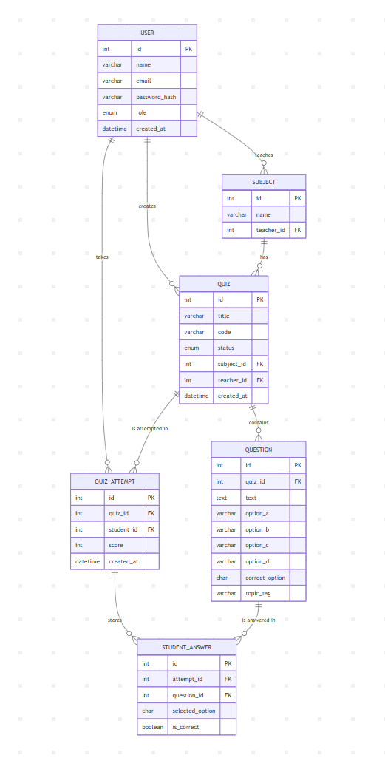

Figure1- ERD made on Mermaid

The ERD in Figure 1 shows that each teacher can own multiple subjects, and each subject can contain multiple quizzes. Each quiz is composed of multiple questions. When a student participates in a quiz, the system creates a QuizAttempt record and stores each answer in the StudentAnswer table. This structure allows us to compute per-question statistics and per-student scores while keeping the database normalised.

**2.2 Data Dictionary (MySQL database explanations)**

Here is the phpMyAdmin localhost view:

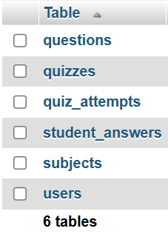

User table:

  
User table in the MySQL database. This table stores all registered accounts for the application. Each row represents either a teacher or a student. The **role** field is used for role-based access control, and **password_hash** contains the bcrypt-hashed password to ensure secure authentication. The most important fields are: **id** (primary key), **email** (unique login identifier), **password_hash** (hashed password), and **role** (either ‘teacher’ or ‘student’).

Subjects table:

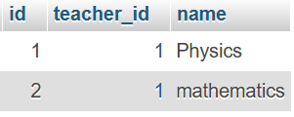

**subjects** table. Each record represents a subject or course created by a specific teacher. The **teacher_id** field is a foreign key referencing the **users** table, which ensures that every subject is always linked to the teacher who owns it.

Student_answers table:

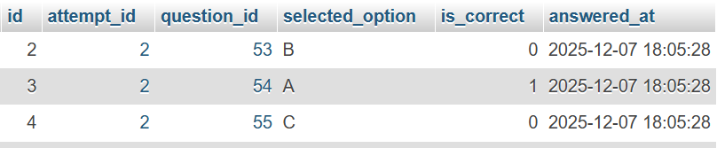

For every quiz attempt, the system stores one row per question answered. It records the selected option and whether it was correct (is_correct). This design allows the teacher to see detailed statistics per question and to identify weak areas in the quiz analysis section.

Quiz_attempts table:

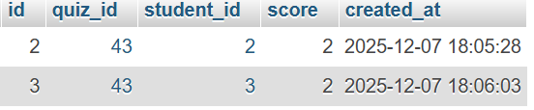

This table records each time a student completes a quiz. The student_id references the users table, and quiz_id references the quizzes table. The score column stores the number of correct answers, and the created_at timestamp is used to display the most recent attempts in the student dashboard.

Quizzes table:

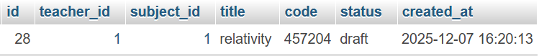

This table stores all quizzes created by teachers. It includes a code column used by students to join the quiz from their dashboard, and a status column (draft, open, closed) that controls the quiz lifecycle. The subject_id and teacher_id foreign keys connect each quiz to its subject and owner.

The status field is also used in the analysis logic: only closed quizzes can be fully corrected and analysed.

Questions table:



Each row is a multiple-choice question belonging to a quiz. The table stores the question text and four options (option_a to option_d), together with the correct_option. An optional topic_tag (for example ai_generated) is used to indicate whether the question was created manually or by the AI module.

**2.3 Website Navigational Structure / Process flow diagrams**

Website navigational structure:

/ (Home)

├─ /login

├─ /register

├─ /teacher/dashboard

│ ├─ /teacher/quizzes/new

│ ├─ /teacher/quizzes/:id/edit

│ ├─ /teacher/quizzes/:id/ready

│ └─ /teacher/quizzes/:id/analysis

└─ /student/dashboard

├─ /student/quiz/:code

└─ /student/quiz/:code/result

1. User Registration & Login Flow

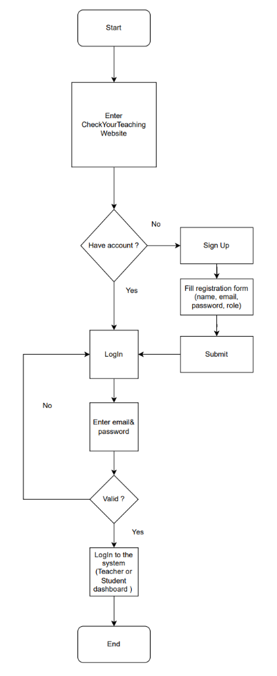

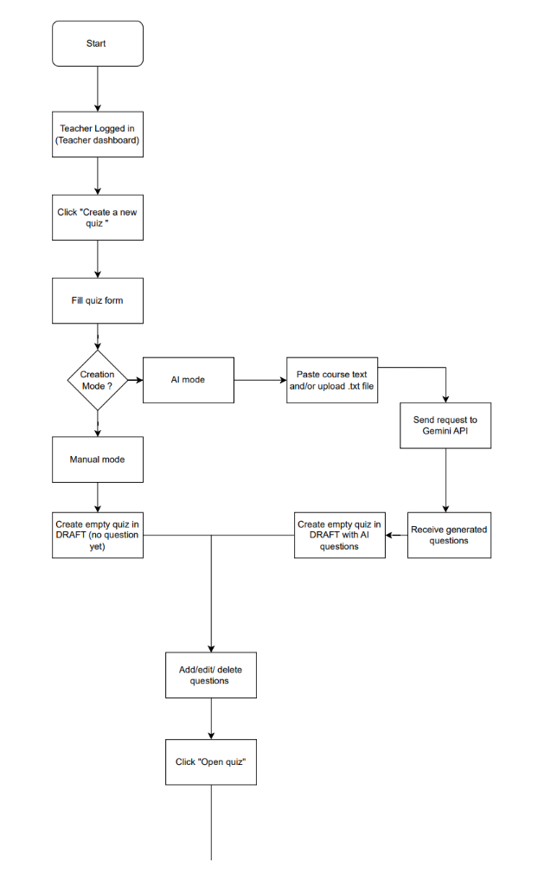2. Teacher – Quiz Creation & Closing

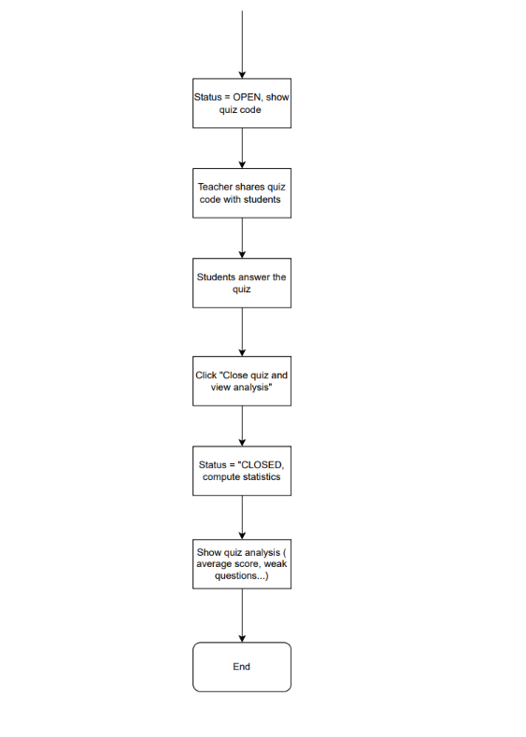

3. Student – Join Quiz, Answer & See Correction

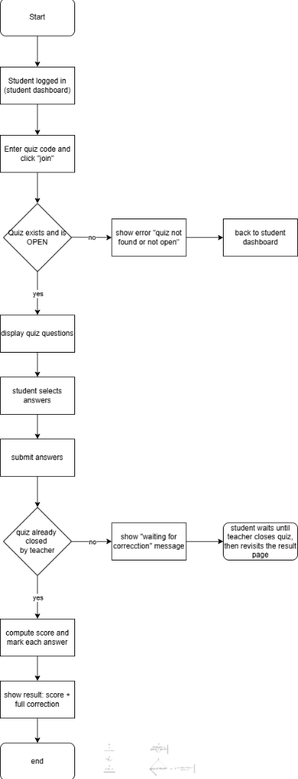

4. Gemini AI –Quiz Generation Flow (Optional)

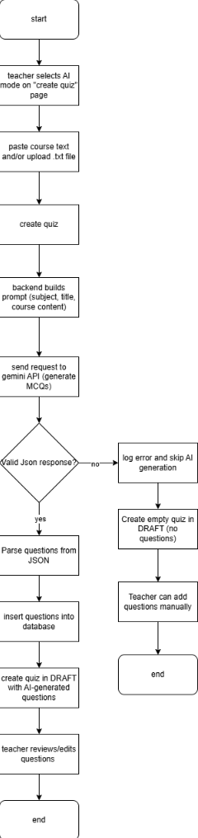

**2.4 User interface (Screenshots instead of wireframes)**

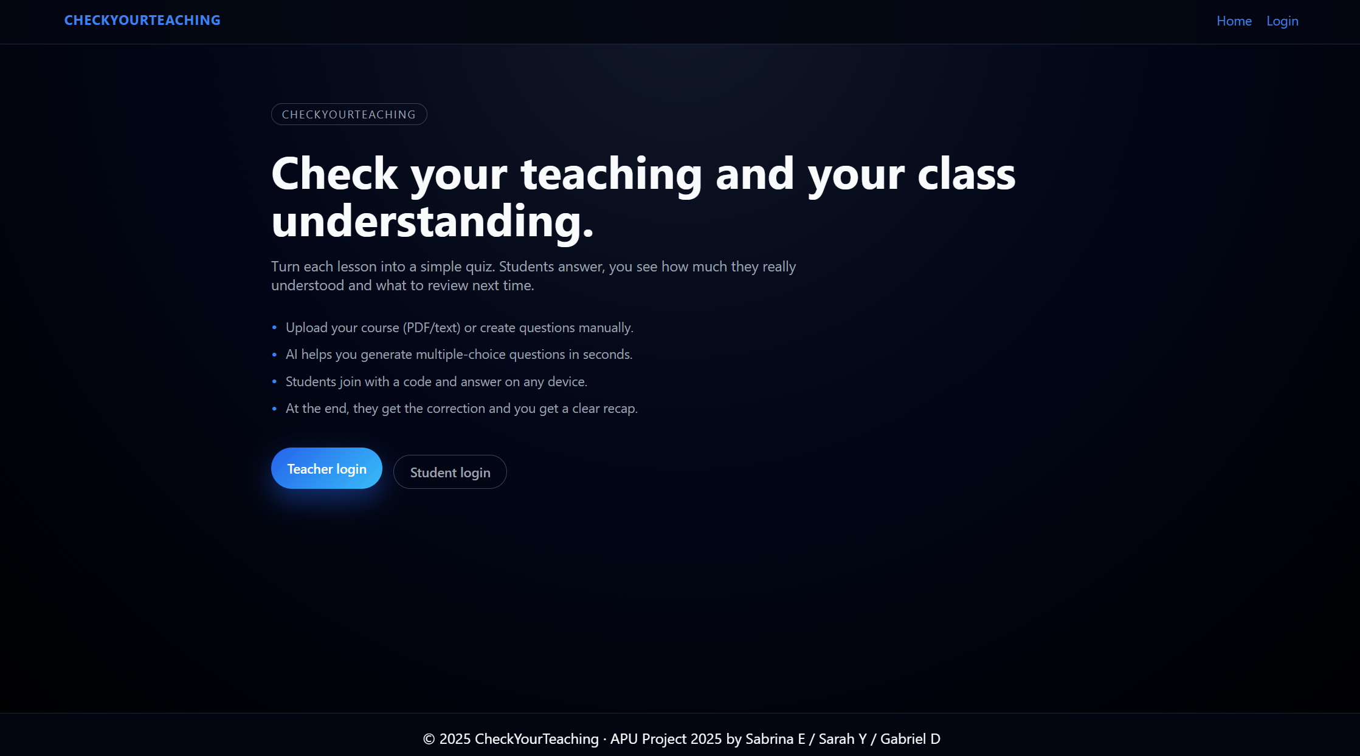

***Figure 1 – Home page.*** *The landing page briefly explains the purpose of CheckYourTeaching and offers two main entry points: “Teacher login” and “Student login”. This keeps the interface simple and directly aligned with the two user roles supported by the system*

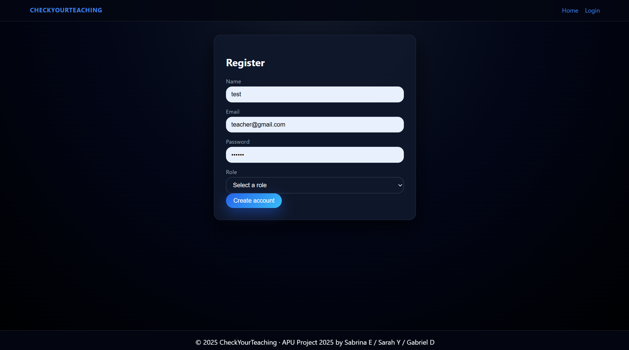

**Figure 2 – Registration page**. New users can create an account by providing their name, email, password, and choosing a role (teacher or student). Server-side validation ensures that all fields are filled and that the email is unique.

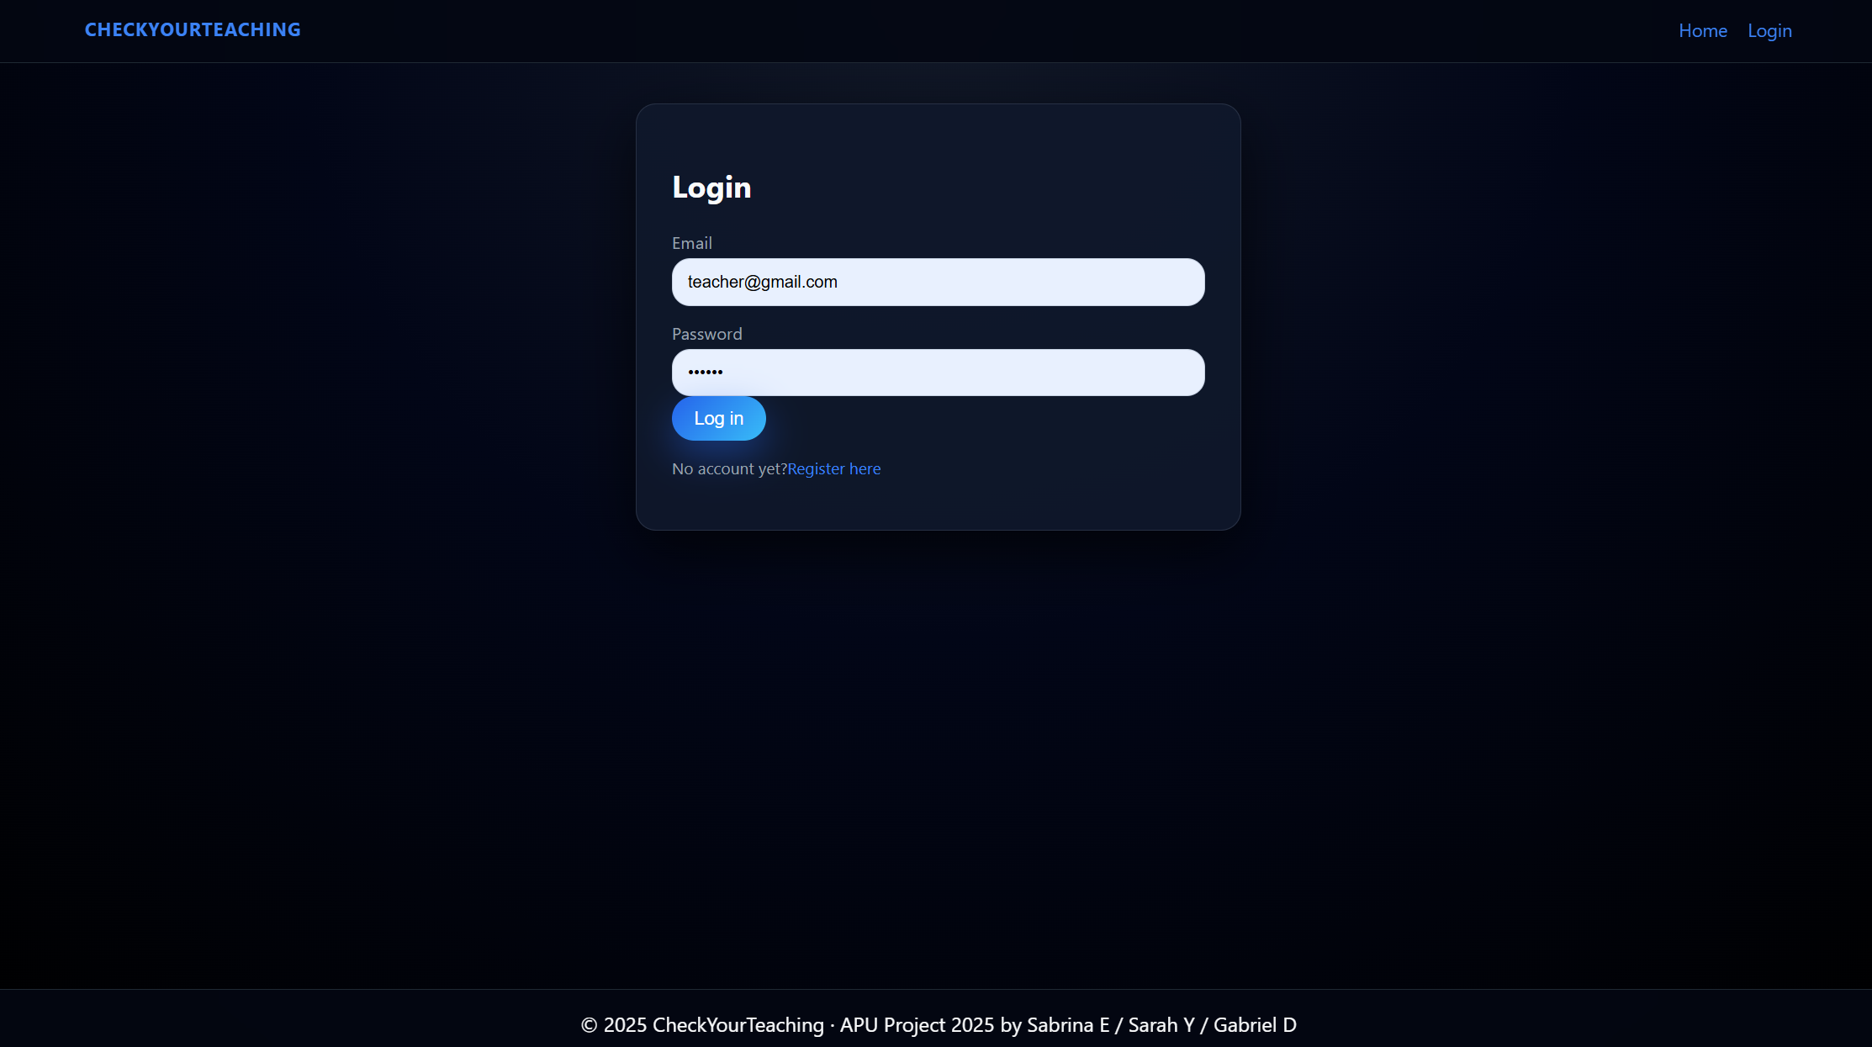

**Figure 3 – Login page**. Both teachers and students log in from the same form using email and password. On success, they are redirected to their respective dashboards depending on their role.

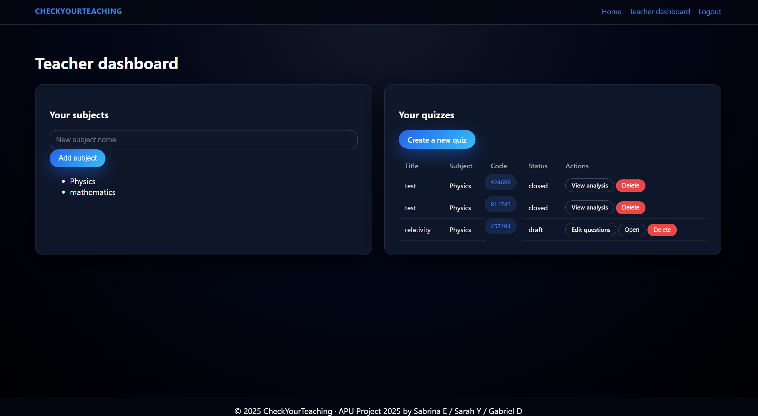

***Figure 4 – Teacher dashboard***. *The left card allows teachers to create new subjects, and the right card lists all quizzes with their title, subject, code, status, and actions. From here, the teacher can open a quiz, edit questions, view the live quiz code, or access the analysis page.*

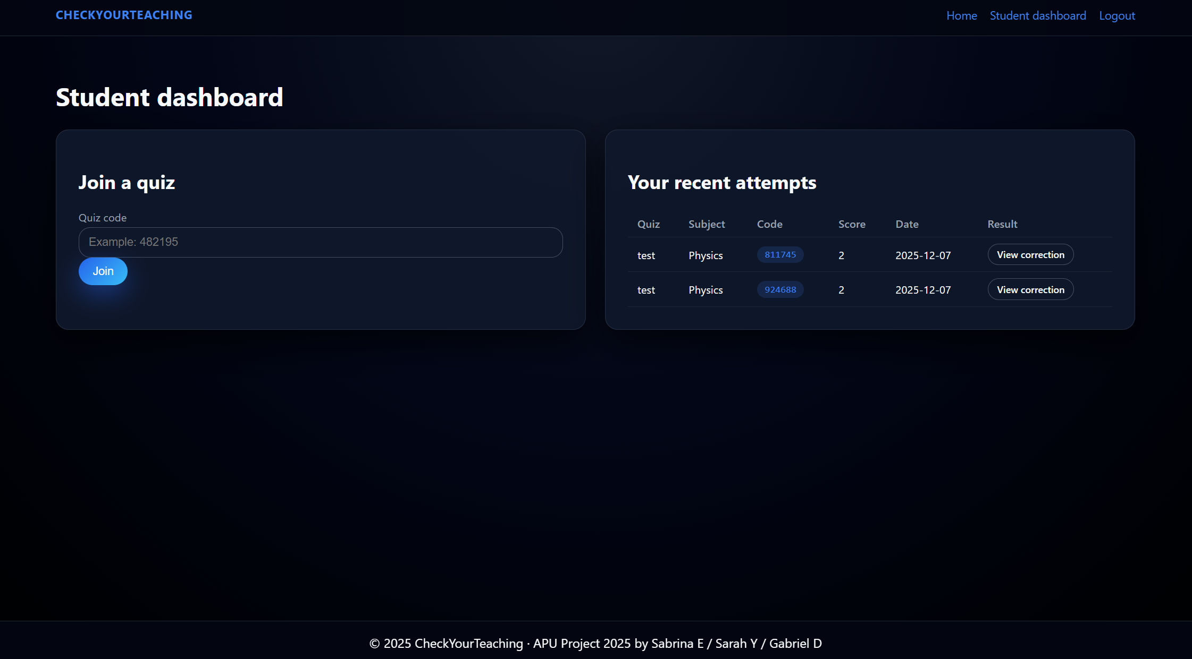

***Figure 4 – Student dashboard****. On the left, the student can join a quiz by entering the 6-digit code given by the teacher. On the right, the table shows the most recent attempts with the quiz title, subject, code, score, date, and a “View correction” button once the quiz has been closed.*

**Quiz participation screens:**

**Teacher views:**

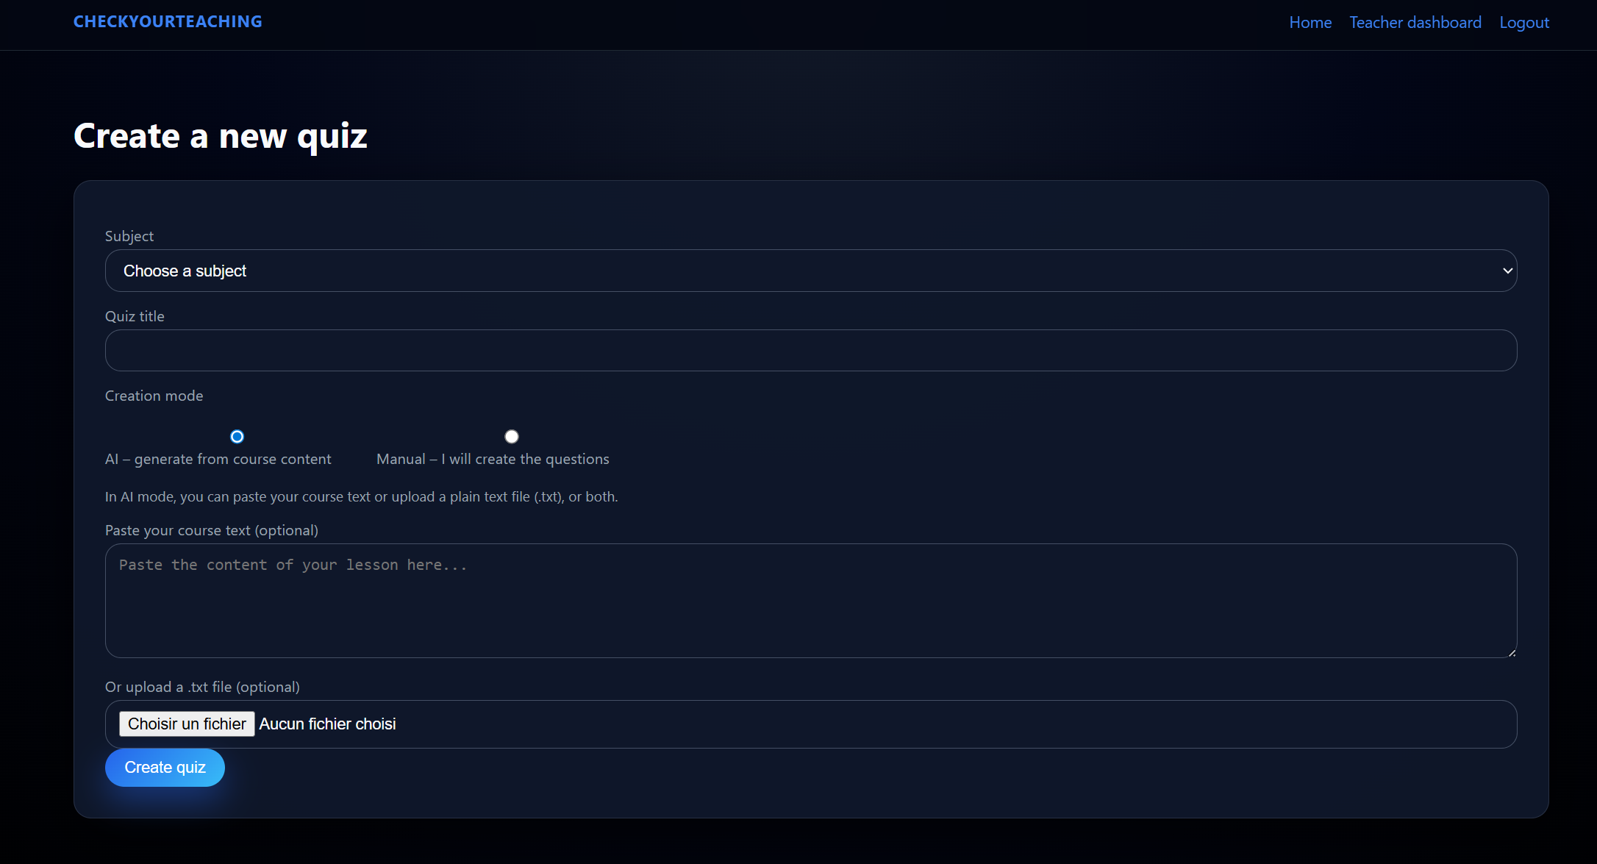

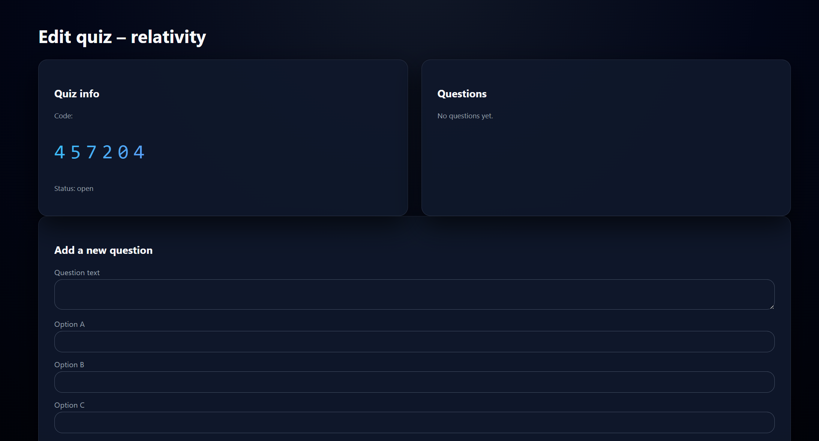

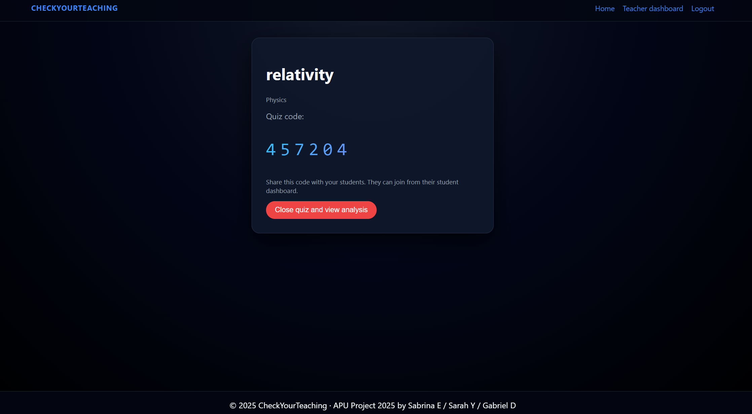

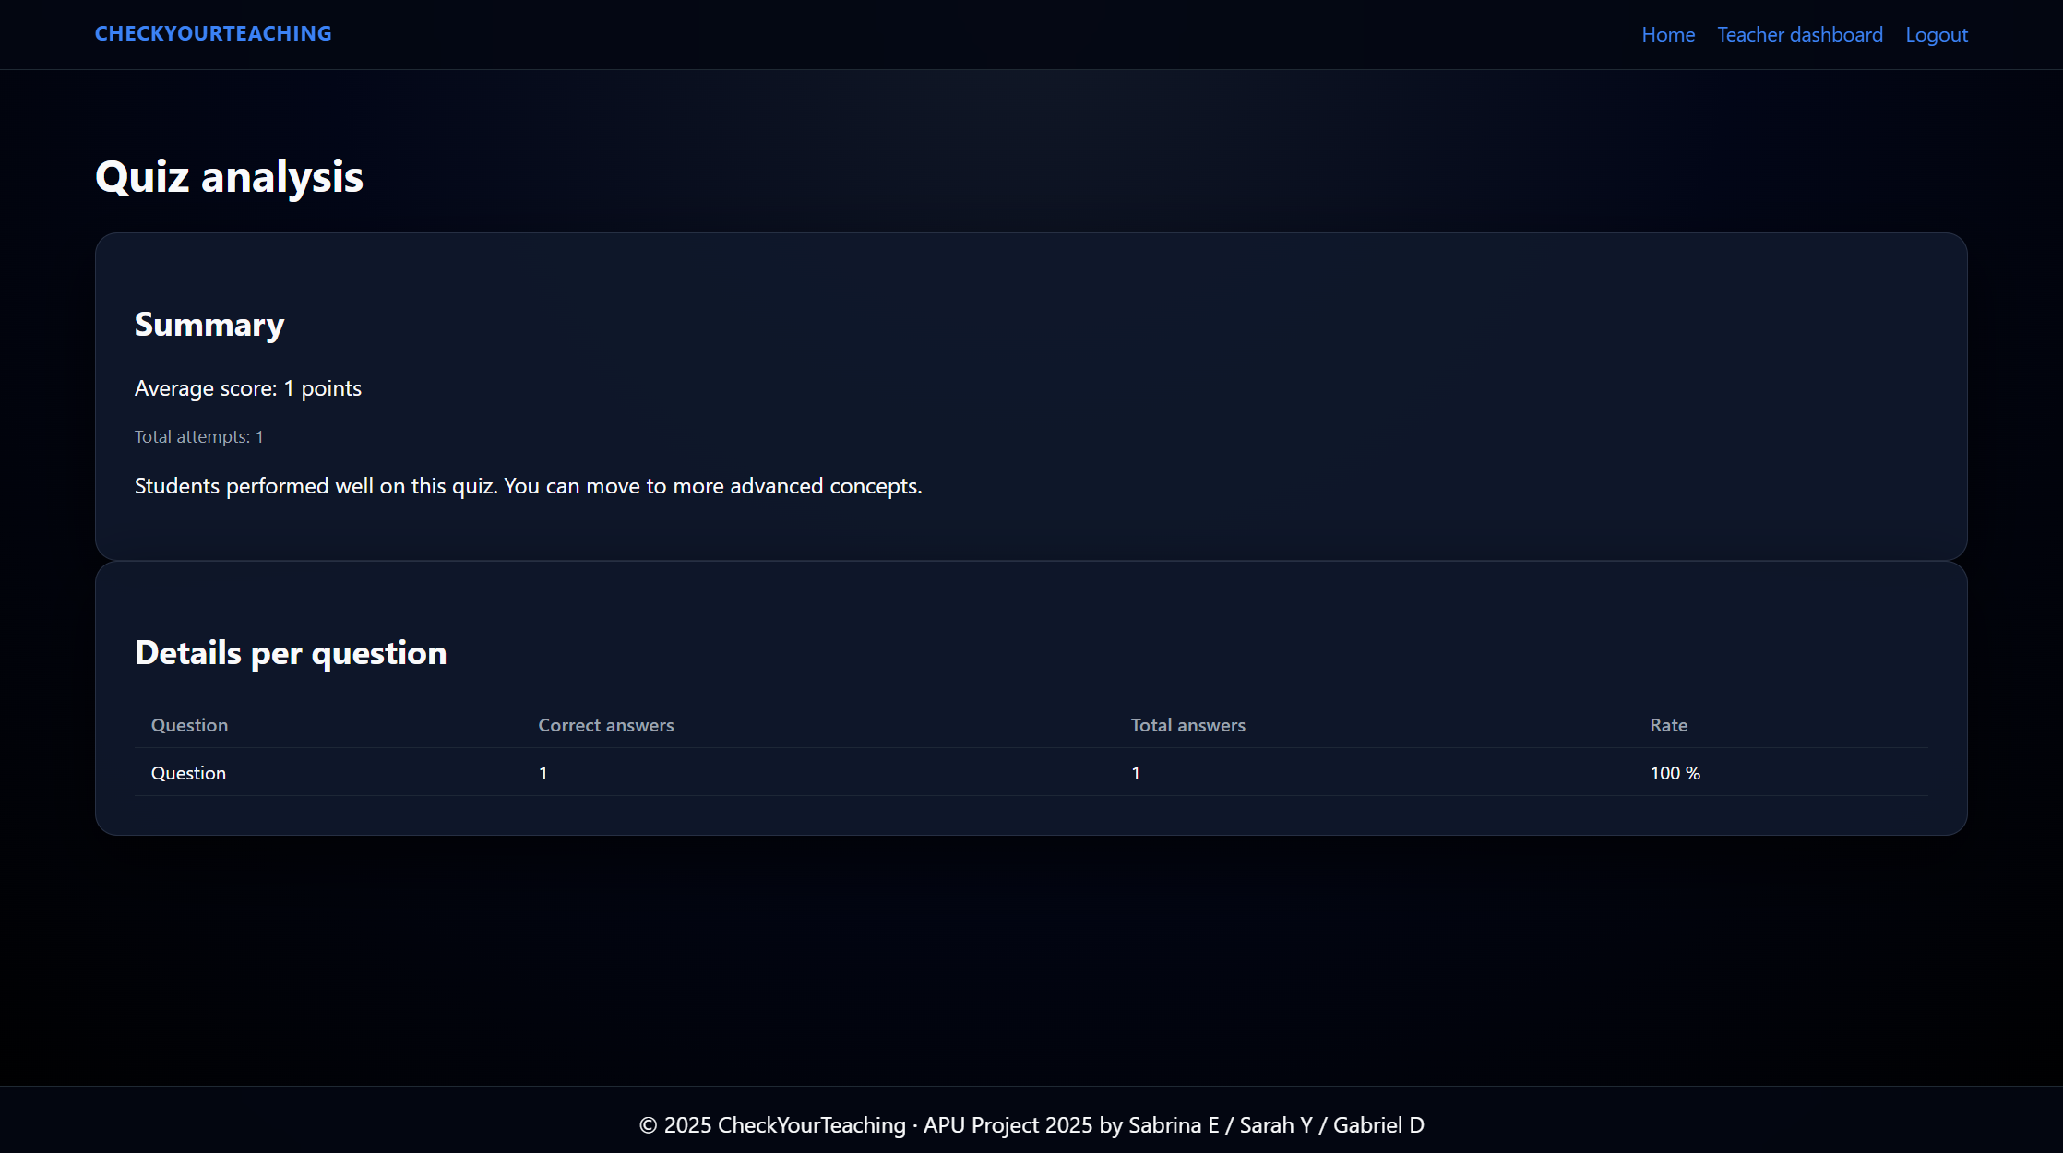

Result and corrections screen. After the teacher closes the quiz, the student sees their score (e.g. 7 / 10) and a detailed correction. For each question, a badge indicates the student’s answer and whether it was correct or not. This design gives students immediate feedback and supports self-evaluation.

**Student views:**

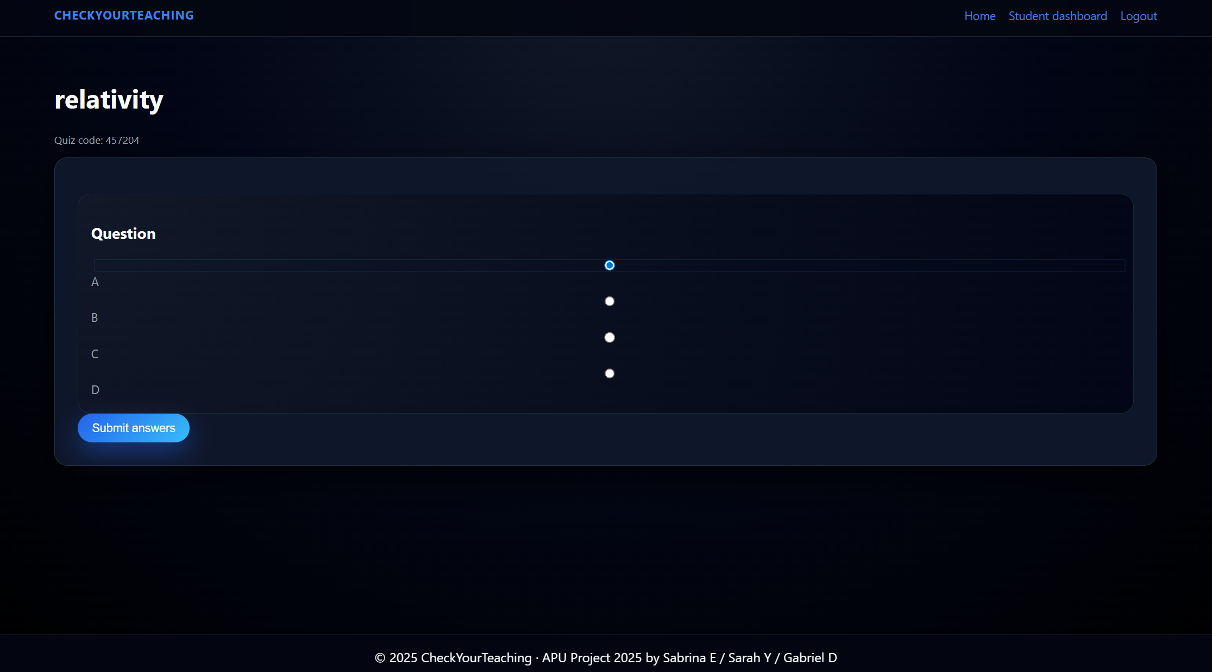

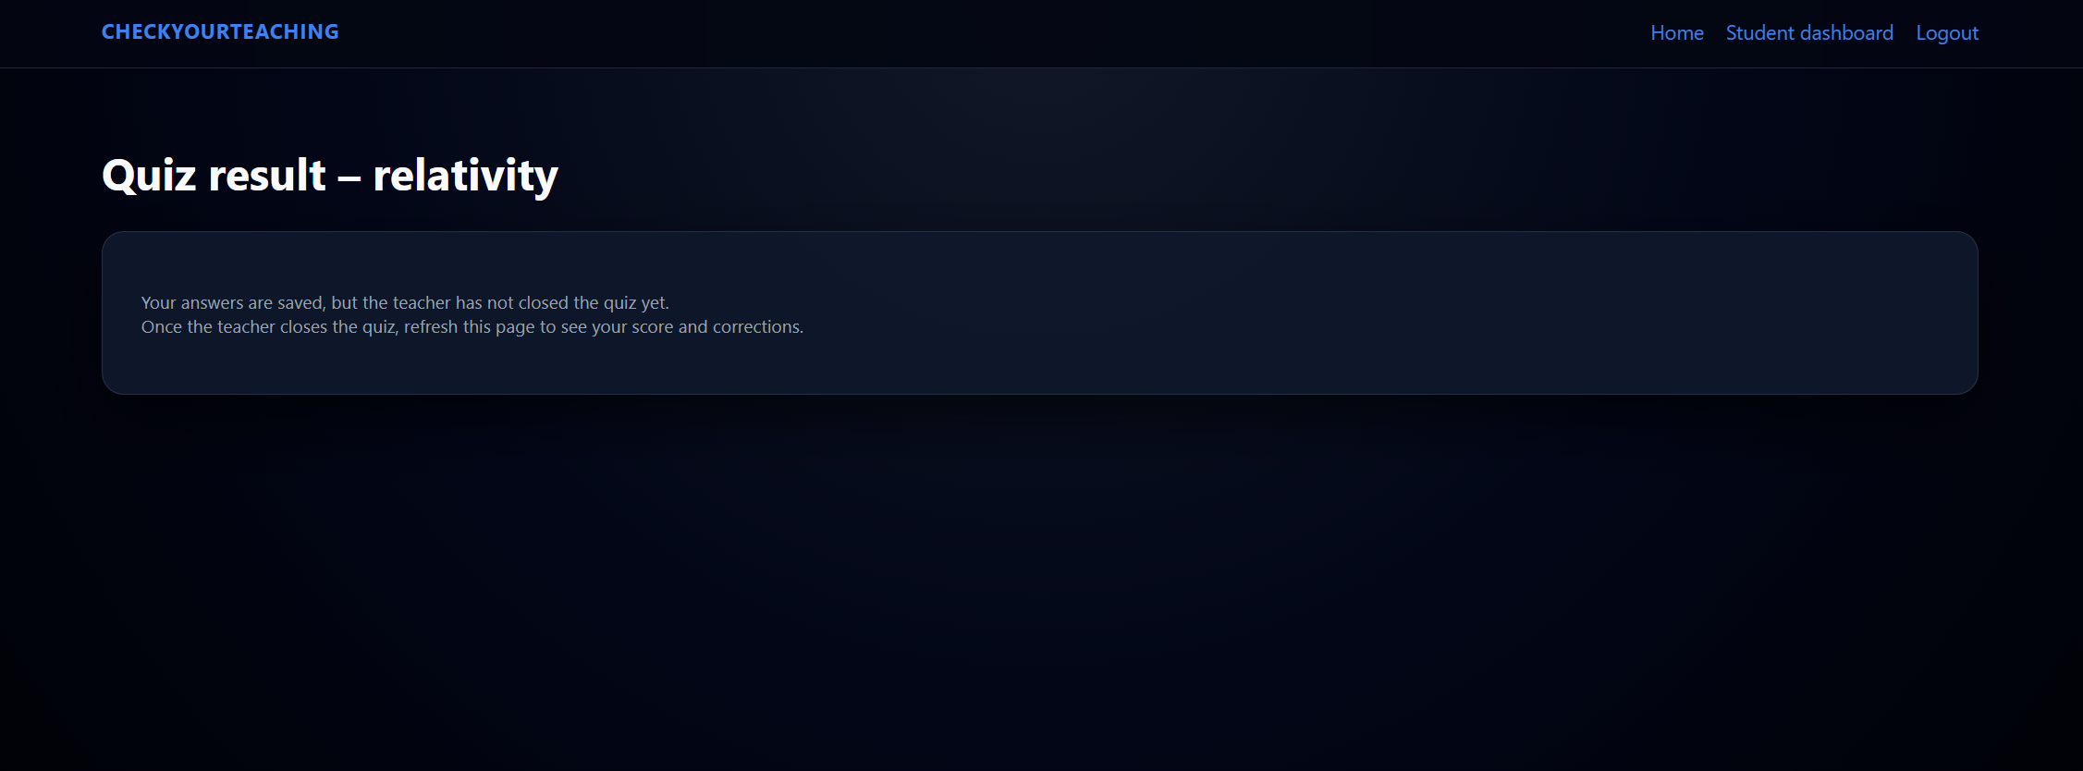

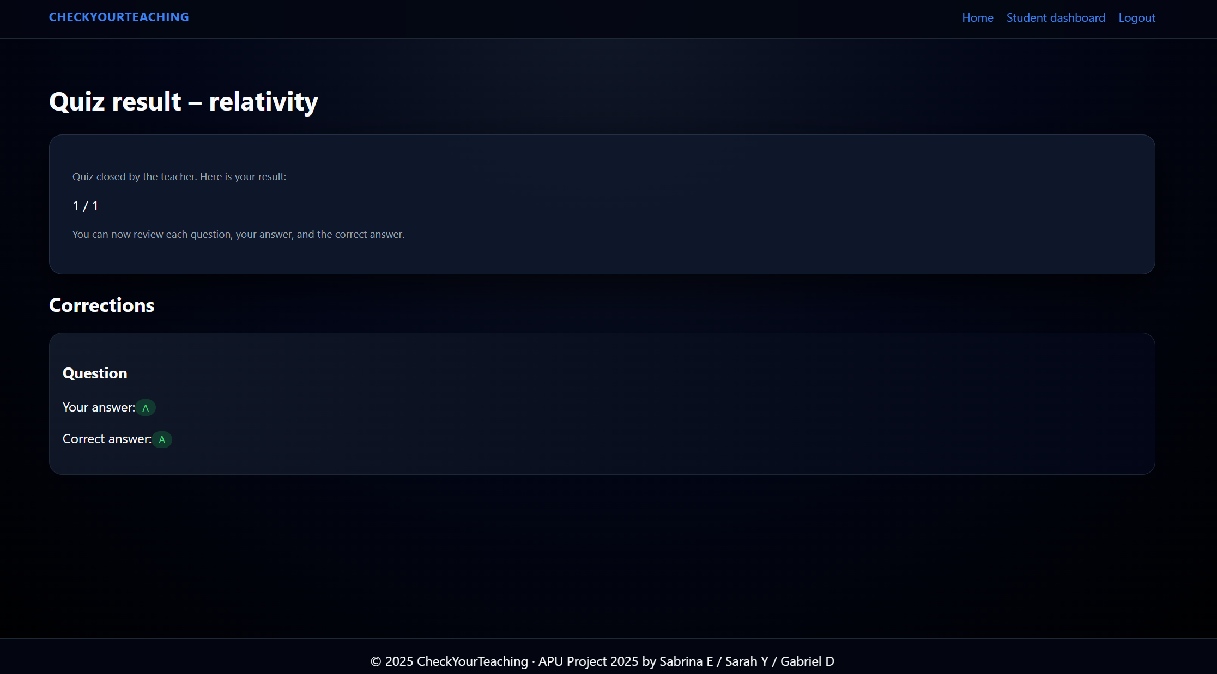

Students answer multiple-choice questions one by one. All questions are displayed on the same page, which keeps the workflow fast for end-of-class quizzes.

# 3. Implementation

**3.1 Backend Architecture**

app.js – main entry point, middleware setup and route mounting

routes/ – route handlers for authentication, teacher and student logic

views/ – Pug templates for all pages (home, dashboards, forms, results, analysis…)

public/ – static files (CSS)

db.js – MySQL connection pool

middlewares/ – shared middlewares (JWT-based authentication and role checking)

services/ai.js – Gemini AI integration for automatic quiz generation.

The app.js file is the entry point, where the Express application is created, middlewares are registered, and all routers are mounted. The routes folder contains route handlers for authentication, teachers and students. The views folder contains Pug templates used to render HTML pages. The public folder holds the global CSS file. The db.js file configures the MySQL connection pool, and the services/ai.js module encapsulates the integration with the Gemini API.

Sensitive configuration values such as database credentials, JWT secret, and the **Gemini API key are stored in a .env** file and loaded via the dotenv package. This keeps secrets outside of the source code.

**3.2 Authentication and User Management**

**References: routes/auth.js + middlewares/auth.js**

**Registration logic**

The POST /register endpoint validates the form data, checks that the email is not already in use, and hashes the password using the bcrypt library. The hashed password is stored in the users table. The user must also choose a role (teacher or student), which is saved and later used to restrict access to routes.

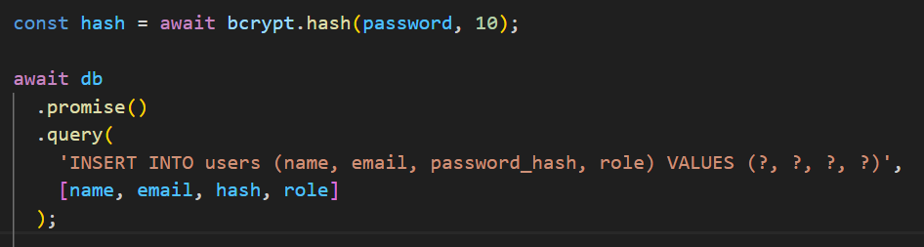

Passwords are never stored in plain text. We hash them using bcrypt with a salt before inserting the user into the MySQL users table.

**Login logic & JWT**

The POST /login endpoint retrieves the user by email, compares the given password with the stored password_hash using bcrypt.compare, and if the credentials are correct, generates a JSON Web Token (JWT). The token stores the user id, name, and role, and is signed using JWT_SECRET. The token is stored in an HTTP-only cookie named token.

During the labs we mostly used simpler session examples; here, JWT goes one step further but follows the same idea: after login, the server remembers who you are and what your role is on each request.

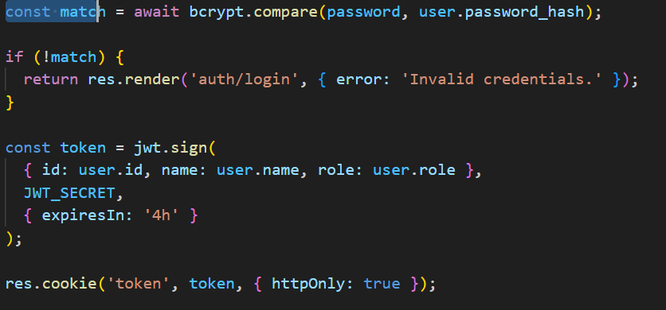

At login, the app verifies the password with bcrypt, then generates a **JWT** that contains the user

id, name and role. This token is stored in a cookie and later read by the **attachUser** and **roleRequired** middlewares.

**Role-based access control**

The authRequired middleware checks whether a valid token is present and redirects unauthenticated users to the login page. The roleRequired(role) middleware enforces role-based access by verifying that the current user has the required role (either teacher or student) before granting access to a route. This mechanism is used at the top of routes/teacher.js and routes/student.js to protect all teacher and student routes.

**3.3 Teacher Features**

References: **routes/teacher.js + views teacher/*.pug.**

**Managing subjects**

*Teachers can create new subjects from the dashboard. The POST /teacher/subjects route inserts a new row in the subjects table, linked to the currently logged-in teacher via teacher_id. The subject list is always filtered by teacher_id, so each teacher only sees their own subjects.*

When the teacher opens /teacher/quizzes/new, the application loads all subjects for that teacher and displays a form where they can choose the subject, enter a quiz title, and select a creation mode (AI or manual). The POST /teacher/quizzes route creates a new quiz with a random 6-digit code and an initial status of draft.

If the AI mode is selected, the route reads both the textarea content and an optional .txt file, combines them into a single text, and calls the generateQuizFromText function from services/ai.js. If valid questions are returned, they are inserted into the questions table. If no questions are generated, the quiz remains in draft mode for manual editing.

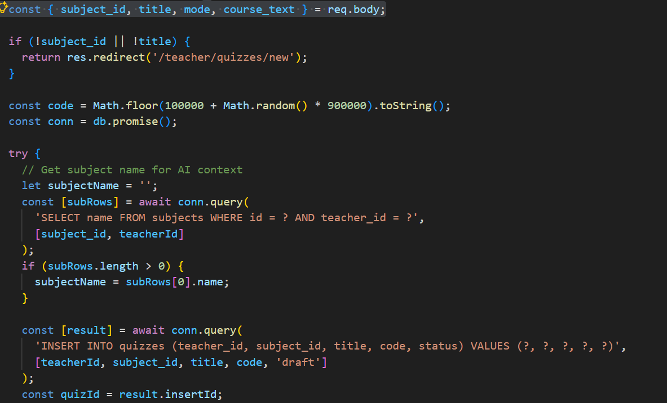

When the teacher submits the quiz creation form, the application generates a random 6-digit code, inserts a new row into the quizzes table with status draft, and returns the new quizId. This code will later be shared with students so they can join the quiz.

Editing quiz questions

*The GET /teacher/quizzes/:id/edit route loads all questions belonging to a quiz and displays them with a small summary and a delete button. A separate form is used to add new questions manually. The POST /teacher/quizzes/:id/questions route performs a basic validation (all fields present) before inserting the new question.*

Opening, closing and analysing quizzes

When the teacher is ready, they can “open” a quiz by clicking the corresponding button, which triggers the POST /teacher/quizzes/:id/open route. This updates the quiz status to open and redirects to /teacher/quizzes/:id/ready, a page that displays the quiz code and subject. Students can now join the quiz using this code.

At the end of the session, the teacher closes the quiz via POST /teacher/quizzes/:id/close, which sets the status to closed and redirects to /teacher/quizzes/:id/analysis. The analysis route calculates the average score, total number of attempts, and per-question statistics (number of correct answers, total answers, and success rate). Questions with a success rate below 60% are listed as “weak questions”, and a short recommendation is displayed to help the teacher plan the next lesson.

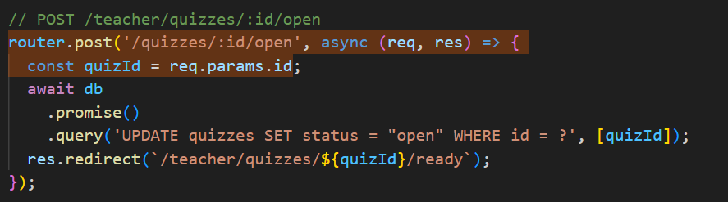

The “Open” action simply updates the quiz status to "open" in the database and redirects the teacher to the “ready” screen, where the quiz code is displayed. Students can now join the quiz using this code.

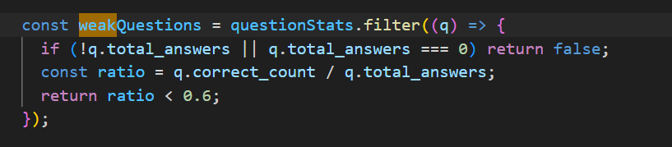

Each question has a number of correct and total answers. The application computes a success ratio and flags questions with less than 60% success as “weak questions”, so that the teacher knows which concepts to review in the next class

**3.4 Student Features**

References: routes/student.js + views student/*.pug

routes/student.js + vues student/*.pug.

**Student dashboard & joining a quiz**

The student dashboard (GET /student/dashboard) displays a form to join a quiz by code and a table of recent attempts. When the student submits the form, the POST /student/join route validates the code and checks that the quiz exists and is open. If not, an error message is displayed. If the code is valid, the student is redirected to /student/quiz/:code.

**Taking a quiz and storing answers**

The GET /student/quiz/:code route first retrieves the quiz using the code. If the quiz is already closed, the student is redirected straight to the result page. Otherwise, all questions for that quiz are loaded and rendered in the take_quiz template.

When the student submits the form (POST /student/quiz/:code), the application creates a new row in quiz_attempts with an initial score of 0, then iterates over all questions. For each question, it reads the selected option, compares it with the correct_option, inserts a row in student_answers, and increments the score if the answer is correct. Finally, the final score is saved in quiz_attempts, and the student is redirected to the result page.

**Viewing results and corrections**

The GET /student/quiz/:code/result route loads the most recent attempt for that student and quiz, together with all related student_answers joined with question texts. If the quiz status is still open, the page only shows a message inviting the student to wait for the teacher to close the quiz. Once the quiz is closed, the page displays the final score (for example 7 / 10) and a detailed correction for each question.

**3.5 AI Quiz Generation (Gemini API – Bonus)**

References: services/ai.js

The services/ai.js module encapsulates the integration with Google’s Gemini API. It is initialised with the GEMINI_API_KEY read from the .env file. The main function, generateQuizFromText, receives cleaned course content, a subject name and a quiz title. It builds a strict JSON-based prompt asking for a list of questions with four options and a correct_option field.

The function then calls model.generateContent, extracts the textual response, and attempts to parse the JSON. If parsing fails or if the API returns an error (for example due to quota limitations), the function simply returns an empty array. This way, the rest of the application remains robust: the teacher can still create and edit quizzes manually even if the AI is not available.

# 4. Error Handling & Robustness

routes/auth.js – POST /register (excerpt):

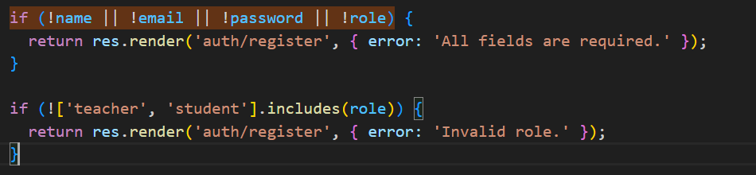

Before inserting a new user, the application checks that all required fields are present and that the role is valid. If not, it re-renders the registration form with an error message. This prevents invalid data from being stored in the database and improves user feedback.

services/ai.js:

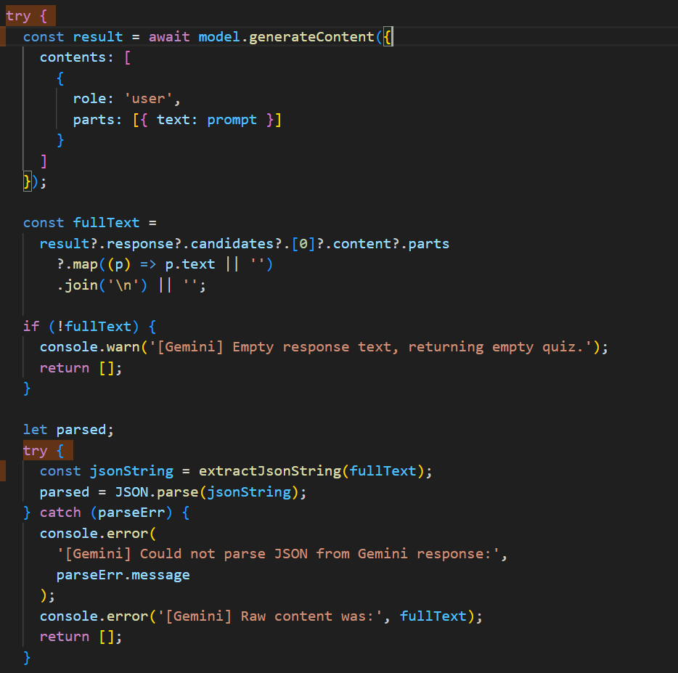

The Gemini integration is wrapped in a try/catch block. If the API fails (for example due to quota limits or network issues), the function logs the error and returns an empty array instead of crashing the server. The rest of the application still works, and the teacher can create and edit quizzes manually.

routes/teacher.js – POST /teacher/quizzes (excerpt)

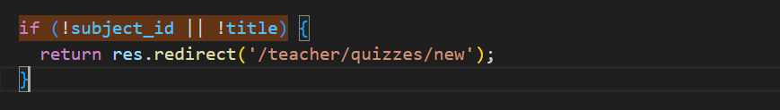

This simple validation ensures that a quiz cannot be created without a subject and a title. If the data is incomplete, the teacher is redirected back to the creation form instead of inserting an invalid row in the database.

# 5. Conclusions & Future Enhancements

**Conclusions**

In this project, we implemented **CheckYourTeaching**, a full-stack web application that helps teachers measure how well their class understood a lesson through quick quizzes. The system provides:

* Secure user management with two clearly separated roles (teacher and student).
* Complete database interaction (CRUD) for users, subjects, quizzes, questions, attempts and answers.
* A modern, responsive interface built with Pug templates and a custom CSS design.
* A teacher dashboard to manage subjects and quizzes, open and close sessions, and see aggregated statistics.
* A student dashboard to join quizzes using a code, answer MCQs and view corrections.

One strong point of the project is the integration of the Gemini API to automatically generate multiple-choice questions from raw course material. This feature goes beyond the standard labs and shows how external AI services can be combined with a classic Node.js + MySQL stack. We also implemented role-based route protection using JWT, which is slightly more advanced than the basic session handling usually seen in introductory examples.

We also encountered realistic issues, such as:

* **API quota limitations** (HTTP 429: “Resource exhausted”) when calling Gemini too frequently.
* Technical constraints when trying to parse PDFs directly, which led us to favour .txt uploads for stability.

These limitations are documented and open the door to several **future improvements**:

* Better support for PDF and Word documents, by converting them to text before sending them to the AI.
* More configurable quizzes (difficulty, number of questions, time limits).
* Additional analytics for teachers (e.g. per-student progression, topic-based statistics).
* A more advanced Gemini usage strategy, with caching and retry mechanisms to avoid hitting the quota too quickly.

Overall, CheckYourTeaching demonstrates that we have understood and applied the key concepts of **Advanced Web Programming**: full-stack development, secure authentication, role-based access control, database CRUD, and integration of third-party APIs to enhance the user experience.

Thank you for reading!

# 6. References

(Example APA-style references you can put at the end.)

* Google. (n.d.). Google Gemini API – Generative AI for developers. Retrieved from <https://ai.google.dev>
* Advanced Web Programming – Course Slides and Lab Sheets.
* Use of Chatgpt to correct errors
* Google documentation …